**Admin Login Documentation**

Dashboard: 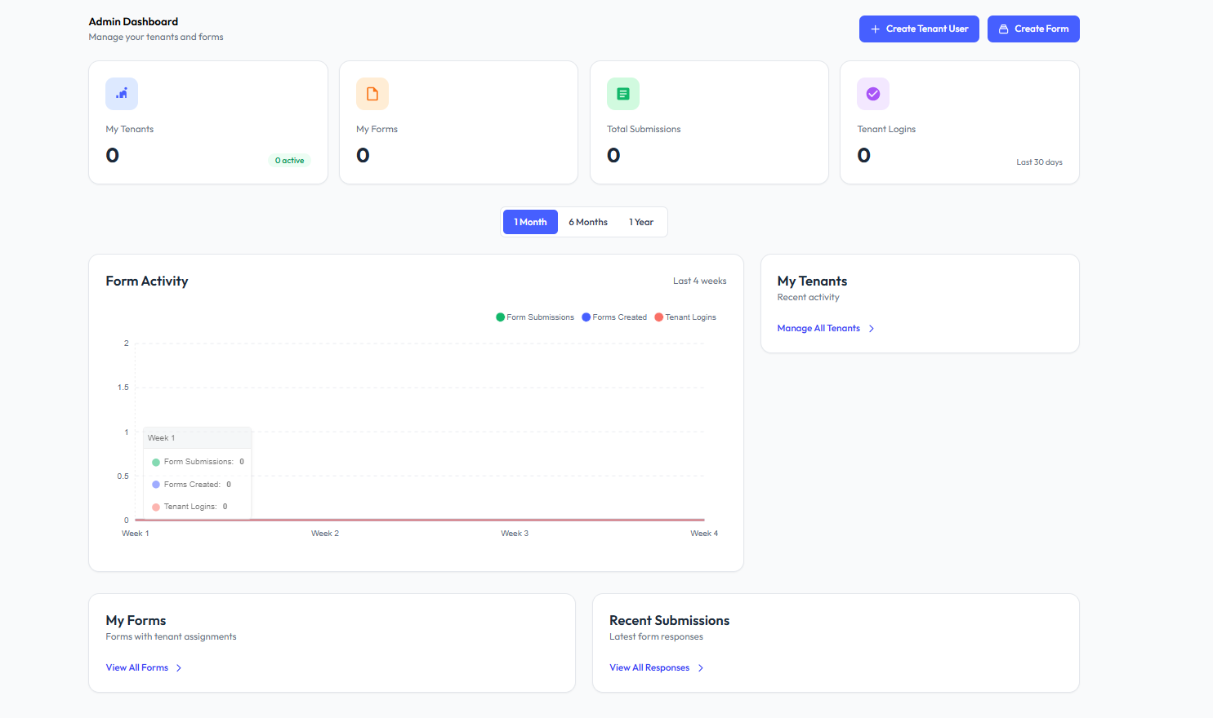

**1. What is the 4Form Admin Dashboard?**

It’s the main screen you see after logging in as an admin. From here, you can manage users (called tenants), create forms, check submissions, and see form activity.

**2. What are the first things I can do here?**

You can:

* ✅ **Create a new user** (tenant)
* 📝 **Create a form**
* 📊 **Track form submissions and logins**

**3. How do I add a new user (tenant)?**

Click on the **"Create Tenant User"** button in the top right corner.  
Fill in the user details and save.

**4. How do I create a form?**

Click on the **"Create Form"** button next to the tenant button.  
Give your form a name, add fields, and assign it to a tenant.

**5. What does “My Tenants” mean?**

It shows how many users (tenants) you have and how many are active.

**6. What does “My Forms” show?**

It tells you how many forms have been created in total.

**7. What does “Total Submissions” show?**

This shows how many people have filled out forms.

**8. What is “Tenant Logins”?**

This shows how many times your users (tenants) have logged in recently.

**9. What is the Form Activity graph?**

This graph shows:

* 📈 How many forms were submitted
* 🛠️ How many forms were created
* 🔐 How many logins happened

You can view this activity by selecting:  
**1 Month**, **6 Months**, or **1 Year**

**10. How can I view all tenants?**

Go to the **“My Tenants”** box and click **“Manage All Tenants”** to see or edit all your users.

**11. Where can I find my forms?**

Scroll down to **“My Forms”** and click **“View All Forms”** to see the list.

**12. How can I check recent form submissions?**

In the **“Recent Submissions”** section, click **“View All Responses”** to see who filled out which form.

Tenant Users:

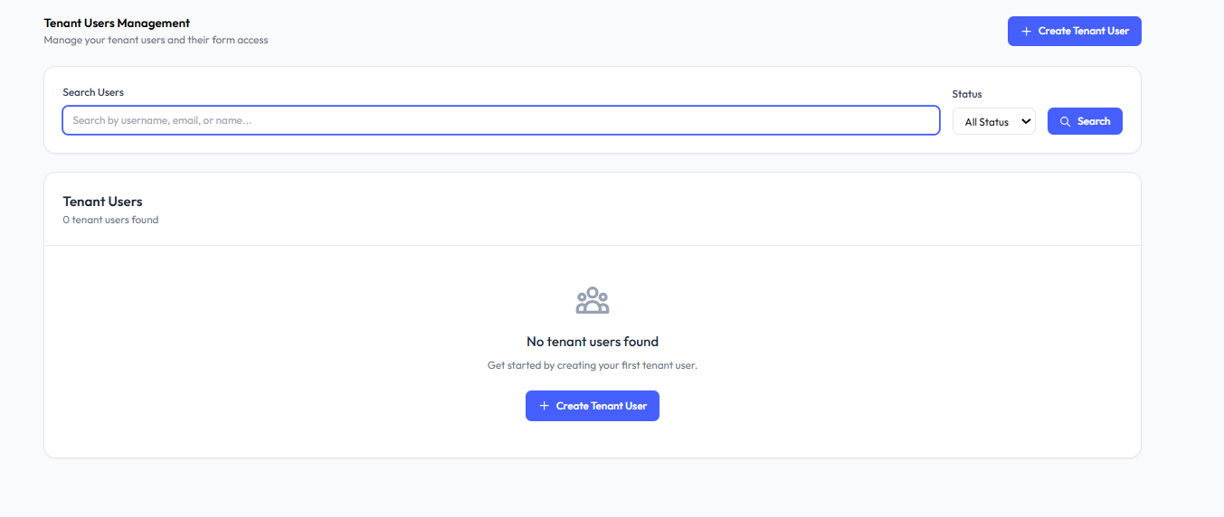

**1. What is the purpose of this page?**

This page helps you **create, search, and manage tenant users**. Tenants are the users who will fill forms or manage their own forms.

**2. What is a “Tenant User”?**

A tenant user is someone (like a client, employee, or team member) who has access to view, fill, or manage forms shared with them.

**3. How can I create a new tenant user?**

Click the **“+ Create Tenant User”** button in the top right (or center if no users exist).  
You’ll be asked to enter details like name, email, etc., and assign form access.

**4. Where do I see the list of tenants?**

Once you add tenant users, they will appear in the **Tenant Users** list section below the search bar.

**5. How do I search for a tenant user?**

Use the **search bar** at the top to find a tenant by typing their:

* Username
* Email
* Name

Then click **Search**.

**6. What is the “Status” filter for?**

The **Status** dropdown lets you filter tenants by:

* ✅ **Active** – Tenants who are currently using the system
* 🚫 **Inactive** – Tenants who are deactivated
* 🔄 **All Status** – Shows both active and inactive users

**7. What does “No tenant users found” mean?**

It means you haven’t created any tenant users yet. Just click **“Create Tenant User”** to add your first one.

Create Tenant User:

**1. What does the “Active User” checkbox mean?**

If this box is checked ✅, the user will be able to **log in** and **access the forms** you assign to them.

If unchecked ❌, the user will be created but won’t be able to log in until activated.

**2. How do I assign forms to a tenant?**

After creating the tenant, go back to the **Tenant Management** page and assign forms to them.

📧 The tenant will get an **email invitation** to set their password and view assigned forms.

**3. What happens after I click "Create Tenant User"?**

The tenant is created in the system, and they’ll receive an email to log in. You can then assign forms to them.

**4. Can I cancel this form?**

Yes. Click the **“Cancel”** button next to **“Create Tenant User”** if you want to stop creating the user.

**Forms:**

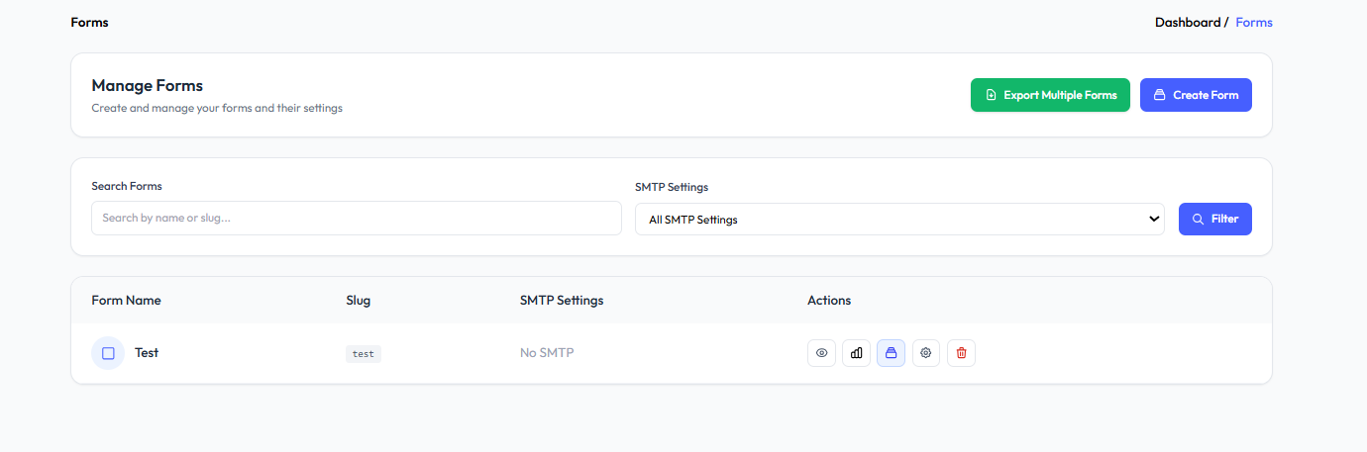

**1. How can I create a new form?**

Click the “Create Form” button on the top right.  
You’ll be taken to the form builder to design your form.

**2. How do I search for a specific form?**

Use the Search Forms bar by entering the form name or slug (short ID).  
Click “Filter” to apply the search.

**3. What is the SMTP Settings dropdown for?**

This lets you filter forms based on their SMTP (email) settings.  
You can choose:

* All SMTP Settings
* Or a specific SMTP setting (if configured)

**4. How can I export form responses?**

Click the “Export Multiple Forms” button.  
This will generate an Excel file containing responses from all your forms.

**5. What information is shown in the form list below?**

Each form row includes:

* Form Name – The title of the form
* Slug – A short, unique identifier
* SMTP Settings – Shows if email is set up
* Actions – Several icons to manage the form

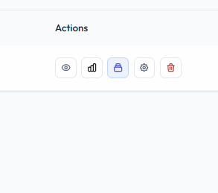

Delete Form

Form Settings

Form Builder

Analytics

View Response

**Form Settings:**

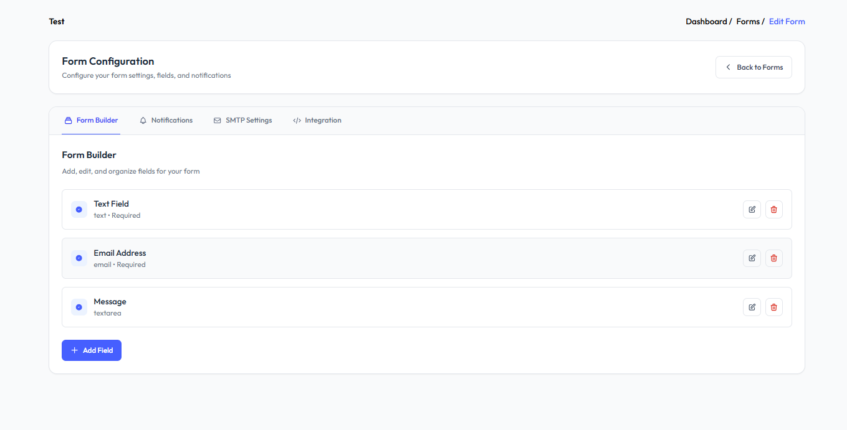

This page is used to **configure and manage all settings related to a form**, including the fields, notifications, email settings, and integration options.

**1. What types of fields can I see here?**

You can see existing fields such as:

* **Text Field** (text, required)
* **Email Address** (email, required)
* **Message** (textarea, not required unless specified)

**2. How can I add a new field?**

Click the **“+ Add Field”** button to create a new form field (like dropdown, checkbox, etc., depending on your options).

**3. How can I edit an existing field?**

Click the **pencil icon** 🖉 next to the field to **edit** its label, placeholder, type, or required status.

**4. How can I remove a field?**

Click the **trash icon** 🗑️ to delete the field from the form.

**Notification:**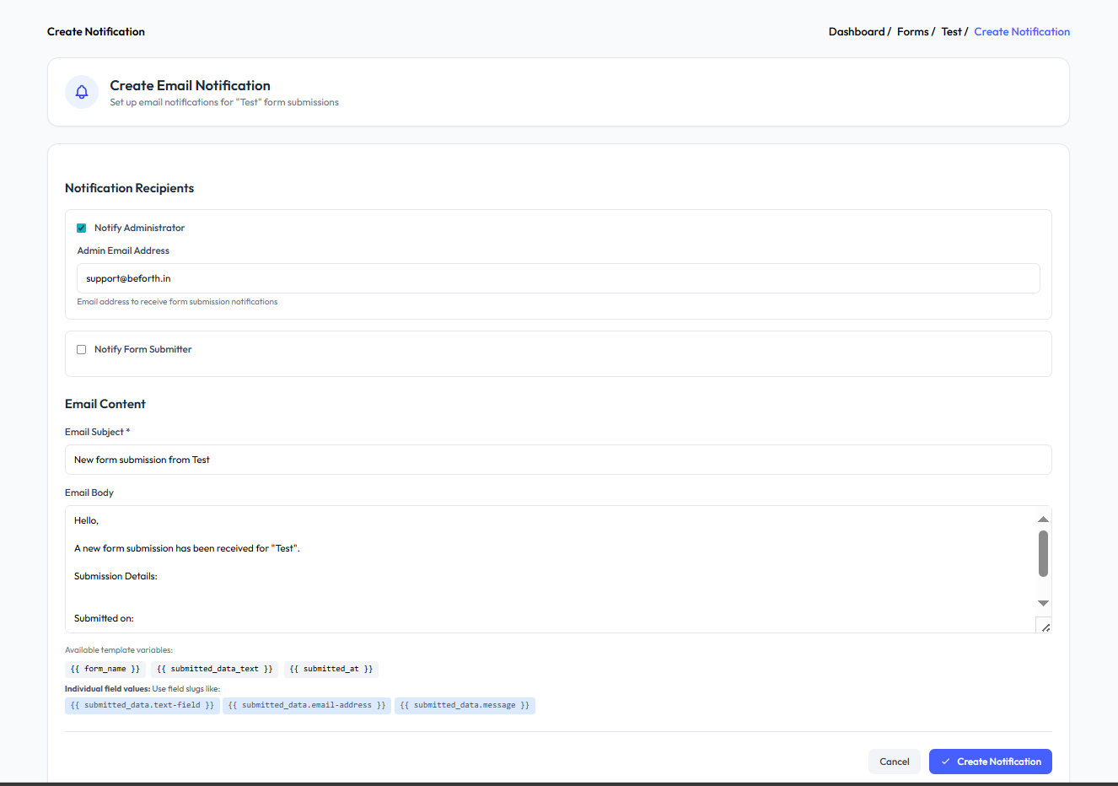

On this page, you can **create email notifications** to alert users when a form is submitted.  
To access this page, go to the **“Notifications” tab** inside the **Form Settings** panel.

**1. How do I notify the administrator?**

* Tick the **“Notify Administrator”** checkbox.
* Enter the email address in the **“Admin Email Address”** field where you want to receive form submissions.

**2. Can I notify the person who submitted the form?**

Yes, enable the **“Notify Form Submitter”** checkbox to send them a confirmation email.

**3. What is the “Email Subject” field?**

This sets the **subject line** of the email you will receive when someone submits the form.

**4. What can I write in the “Email Body”?**

You can customize the message that appears in the email.  
You can also use **template variables** like:

* {{ form_name }} – Form’s name
* {{ submitted_data_text }} – All submitted data
* {{ submitted_at }} – Submission date/time

You can also show **individual field values** like:

* {{ submitted_data.text-field }}
* {{ submitted_data.email-address }}
* {{ submitted_data.message }}

**5. What does the “Create Notification” button do?**

It **saves your notification settings** and starts sending emails based on the configuration.

**SMTP Settings:**

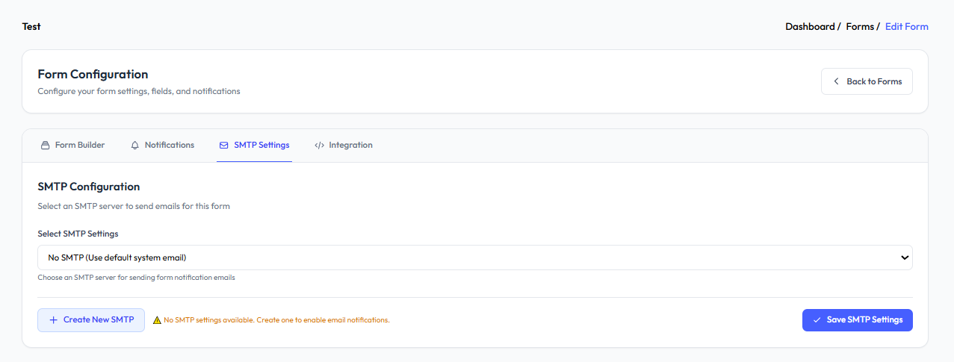

You can set up the SMTP configuration for your form from this page. This allows you to control how email notifications are sent when someone submits your form.

**Integration:**

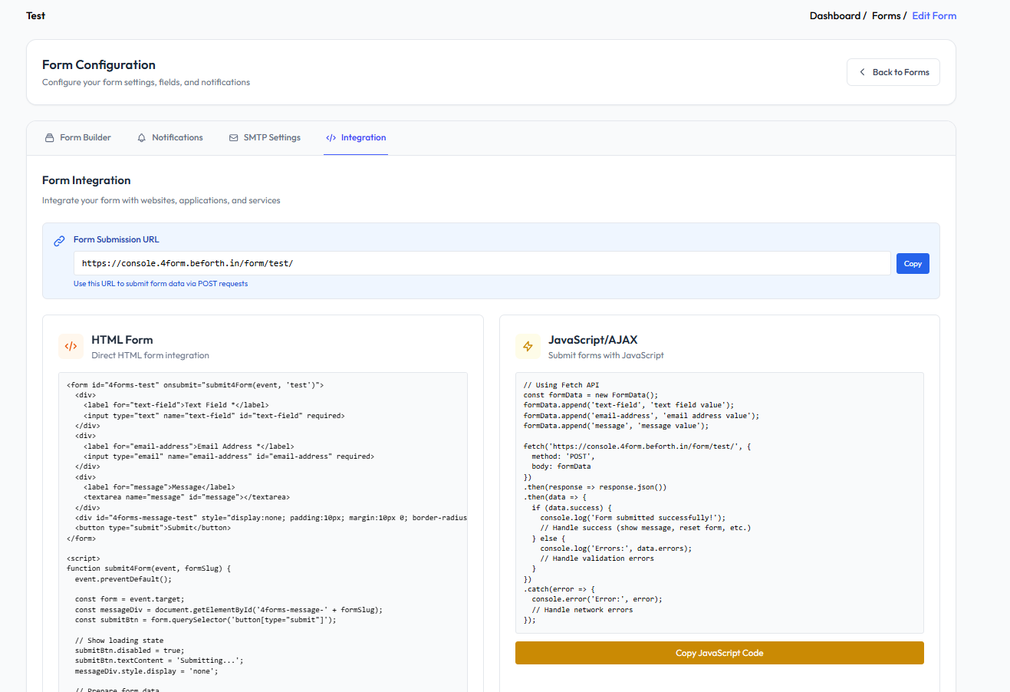

**Q1: What can I do from the Form Integration section?**

From the Form Integration section, you can easily integrate your form into any website, application, or service. This page provides ready-to-use code and instructions for several popular technologies, making it simple to collect submissions directly from your own platform.

**Q2: Which technologies are supported for form integration?**

You can connect your form using the following methods:

* **HTML Form**
* **JavaScript/AJAX**
* **Python Request**
* **cURL Command**

**Q3: How do I integrate the form using an HTML Form?**

You’re given a complete HTML code snippet that you can place directly into your website. This lets visitors fill out and submit the form via a traditional HTML POST method, sending data straight to the provided Form Submission URL.

**Q4: How do I use JavaScript or AJAX to submit the form?**

Step-by-step JavaScript/AJAX code is provided. You can copy this code and use it to send form data asynchronously from your website without reloading the page. This is ideal for modern web apps looking for a seamless user experience.

**Q5: Can I integrate the form into Python scripts or backends?**

Yes. The integration page offers a sample Python requests code snippet. You can use it in your backend scripts or automation tools to send data to the form endpoint programmatically, enabling flexible server-side usage.

**Q6: Is there support for sending form data with cURL?**

Absolutely! You’ll get a cURL command ready to copy and run. This is especially useful for testing or integrating form submissions within bash scripts or other command-line tools.

**Q7: Where do I find all these code samples?**

All code samples are conveniently displayed on the Form Integration page, each pre-filled with your form’s unique submission URL. You can copy any snippet to integrate the form quickly using your preferred technology.

**Q:8 Why use these integration methods?**

These technologies cover a wide range of use cases—from simple HTML websites to advanced web applications, backend services, and automation scripts. This flexibility ensures your form can collect responses wherever you need, using the stack you prefer.

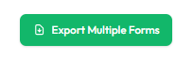

**Export Multiple Forms:**

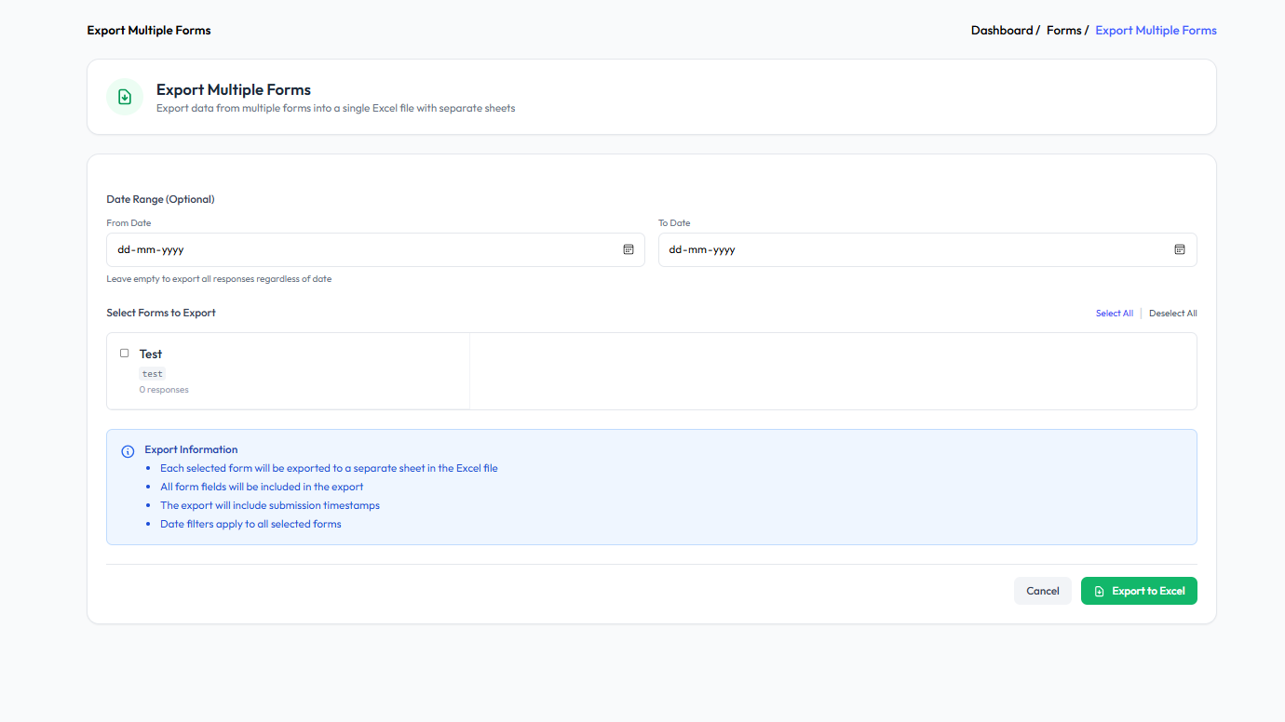

**1. How can I filter responses by date?**

You can use the “From Date” and “To Date” fields to select a date range.

* This will export only the responses submitted within the selected dates.
* If left empty, all responses will be included.

**2. How do I select which forms to export?**

In the “Select Forms to Export” section:

* Tick the checkbox next to each form (e.g., Test) you want to include.
* You can use “Select All” or “Deselect All” for quick selection.

**3. How do I complete the export?**

Click the green “Export to Excel” button at the bottom right.  
To cancel the action, click the “Cancel” button.

**Responses:**

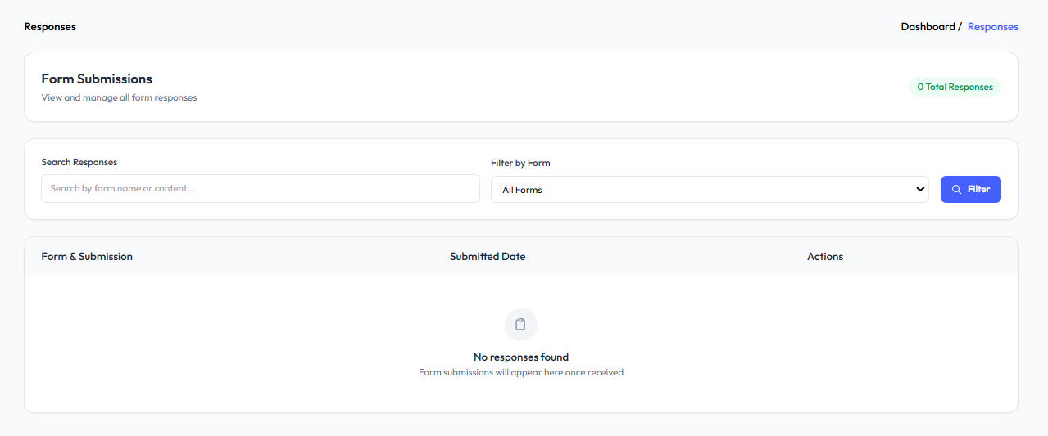

**Q1: Can I filter responses by a specific form?**Yes, you can filter responses to see submissions from a specific form or view responses from all forms.

**Q2: Is it possible to search through the responses?**Yes, you can use the search bar to search for specific responses based on keywords or details within the submissions.

**Q3: How do I view only responses from one particular form?**Select the desired form from the filter dropdown to display responses for that specific form only.

**Q4: What should I do if I have many responses and want to find a certain one quickly?**Use the search bar at the top of the Responses page to enter relevant keywords, and view only the submissions that match your search

**SMTP Settings:**

**Q: What can I do on the SMTP Settings page?**

You can view all existing SMTP server configurations, manage them, and create new SMTP settings for sending email notifications and form responses from your application.

**Q: How do I create a new SMTP setting?**

Click on the Create SMTP Setting button at the top right or the middle of the page (if no SMTP settings exist). This opens a form where you can enter the required SMTP configuration details.

**Q: Is it possible to search or filter SMTP settings?**

Yes. The search bar allows you to look up SMTP settings quickly by entering keywords such as the server name, host, or username.

**Create SMTP Setting:**

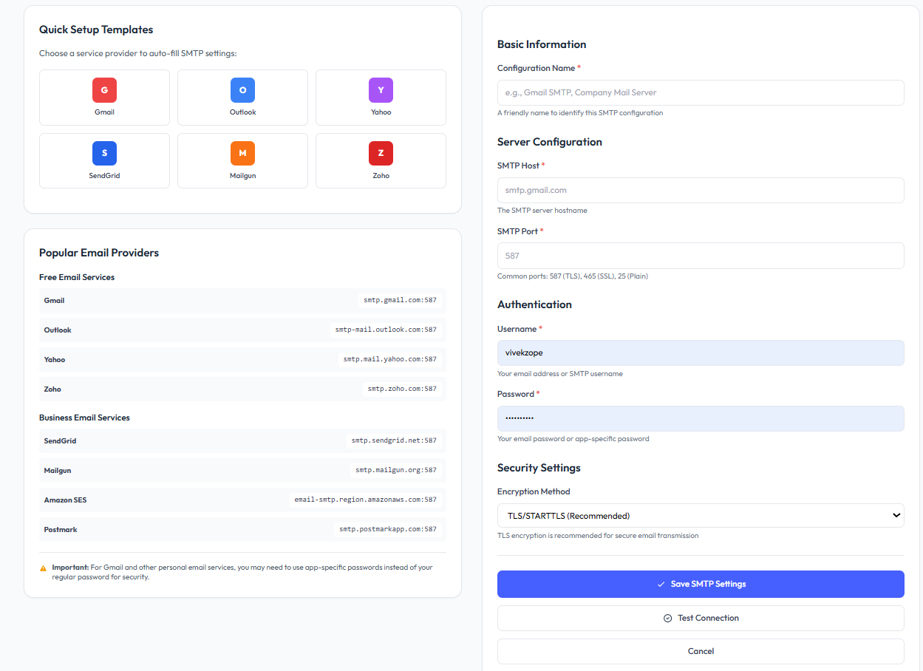

**Q: What is the main purpose of this page?**

This page lets you set up and manage SMTP (Simple Mail Transfer Protocol) server settings, which are required to send emails (such as notifications and alerts) directly from your system or application using your preferred email provider.

**Q: What are the main features available on the SMTP Configuration page?**

* Quick Setup Templates:  
  Choose from popular email service providers (such as Gmail, Outlook, Yahoo, SendGrid, Mailgun, and Zoho) to auto-fill standard SMTP settings.
* Popular Email Providers Reference:  
  A table with SMTP host addresses and ports for common free and business email providers, making manual setup easier.
* Add/Edit SMTP Setting:  
  A customizable form to enter all required SMTP details, including basic info, server configuration, authentication, and security options.
* Security Options:  
  Selection of encryption methods like TLS/STARTTLS or SSL for secure email transmissions.
* Save Settings:  
  Button to save your SMTP configuration.
* Test Connection:  
  Option to test the connection and validate the SMTP details before using them for sending emails.

**Q: What fields are available for configuring a new SMTP setting?**

| **Field** | **Description** |
| --- | --- |
| Configuration Name | Provide a descriptive name so you can identify this SMTP profile for future reference. |
| SMTP Host | The address of your email provider’s SMTP server (e.g., smtp.gmail.com). |
| SMTP Port | The port for connecting to the server (587 for TLS, 465 for SSL, 25 for plain). |
| Username | The email address or username required to log in to the SMTP server. |
| Password | The password or app-specific password for SMTP authentication. |
| Encryption Method | The security protocol for sending emails (TLS/STARTTLS recommended for most providers). |

**Q: What are Quick Setup Templates and how do they help?**

Quick Setup Templates are one-click options for the most common providers (like Gmail, Outlook, Yahoo, etc.). When you select a provider, the system will automatically populate the SMTP host and port fields with the recommended values, simplifying the process and reducing errors.

**Q: How do I manually enter SMTP details?**

Fill in each field as per your provider’s instructions (using the reference table provided), enter your credentials, choose an encryption method, and then save the configuration.

**Q: Is my password secure on this page?**

Passwords are entered in a masked format. For additional security, many providers require you to use app-specific passwords (especially Gmail, Yahoo, etc.) instead of your actual account password.

**Q: What does the 'Test Connection' button do?**

It attempts to connect to your SMTP server with the provided settings, allowing you to verify credentials and connectivity before relying on them for actual email sending. If there’s an error (such as a wrong password or server address), it will alert you.

**Q: Can I use both free and business email services?**

Yes. You can configure SMTP using free email providers (e.g., Gmail, Outlook, Yahoo), or business-grade services (like SendGrid, Zoho, Mailgun, Amazon SES, Postmark). The reference table supplies the standard SMTP settings for each provider.

**Q: What security methods are available?**

* TLS/STARTTLS: Recommended for most providers for secure email transmission.
* SSL: Can also be used if supported by your mail server.
* None: Not recommended, as emails could be sent unencrypted over the internet.

**Q: What should I do if my provider requires an app-specific password?**

Follow your email service provider’s instructions to generate an app-specific password and use that in place of your regular email password for SMTP authentication. This is a common security requirement for providers like Gmail and Yahoo.

**Q: Am I able to integrate multiple SMTP servers?**

You can create and save separate configurations for different email providers or purposes, choosing the most appropriate one as needed. This is useful if you have multiple forms, departments, or notification channels that require different email accounts.

**Q: What happens after I save my SMTP settings?**

The configuration is saved for use by your system. You can send test emails to confirm delivery and make changes at any time if you need to switch providers or update credentials.

**Notifications:**

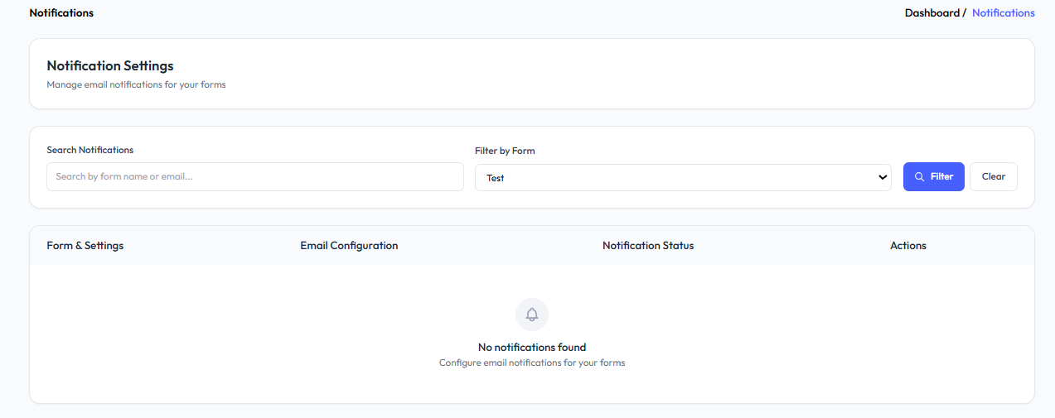

**Q: What can I do on this page?**You can set up, search, and filter email notification configurations for any of your forms to ensure that you, your team, or your users are alerted whenever a form submission occurs.

**Q: How can I find a specific notification setting?**Use the Search Notifications bar to locate notification settings by form name or recipient email.

**Q: Can I filter notifications by a specific form?**Yes, use the Filter by Form dropdown to view notification settings for a particular form, then click Filter to display only those settings.

**Q: Can I configure notifications for multiple forms?**Yes, you can set up and manage distinct notification settings for each form individually using this page.